**Utilization of Algorithms, Dynamic Programming Optimization**

|  |  |
| --- | --- |
| **Date** | 11 November 2022 |
| **Project ID** | PNT2022TMID41871 |
| **Project Name** | Real-Time River Water Quality Monitoring and Control System |
| **Maximum Mark** | 2marks |

**INTRODUCTION**

Since its inception in the mid-nineteenth century by "Richard Bellman," dynamic programming (DP) has been successfully applied to a wide range of issues in a variety of areas [1, 2]. One of the most important features of DP is potential to adjust for a structure's dynamics, and it is usually utilized by operations investigators to address problems existence decisions.

# DISCUSSION ON THE UTILIZATION OF DYNAMIC PROGRAMMING

Dynamic programming (DP) is the process which can easily be

utilized to solve problems related to scheduling. Many researches executed the dynamic programming in the scheduling problems. Other then scheduling exercises offered process of heuristic solution by implementing dynamic programming to determine the employment of out-sourcing as a mean to overcome the disruptions related to the supply chain in manufacture scheduling for unexpected consumer orders. The while a study conducted by in this study author established a program to schedule surgical procedure at the hospital to reduced time of waiting, overtime in operating room and bed availability in ward.

# ALGEBRAIC DYNAMIC PROGRAMMING (ADP)

Exact solutions of many problems can be obtained through dynamic

programming (DP) algorithms especially in biology computations, more over in sequence alignment, scoring of phylogenetic trees and hidden Markov models (HMMs). Evaluation of distribution of score

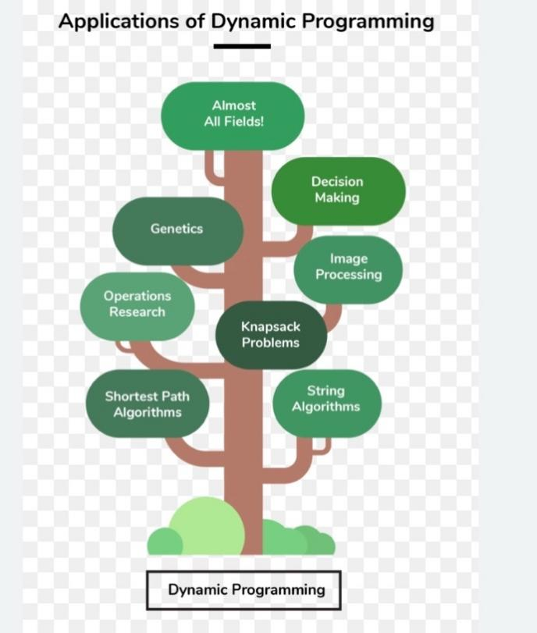

performing stochastic sampling and competitions for optimal solutions can be done via structurally analogous algorithms.

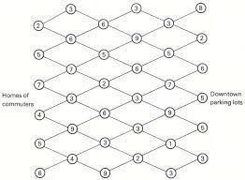

**DP PROBLEM APPROACHES**

According to the researches, the essential element and approximated solutions are determined before the decision rule is being used to make or propose judgments, and when decisions are taken, the algorithm updates its estimate of the problem structure and the ultimate decision rule. Several algorithms which are real time learning based have the benefit of not having precise utility functions for the fundamental inclinations, assumptions, and “laws of motion” that ensures the integrity of the basic problematic situation. An additional notable difference is either the learning is evaluated.

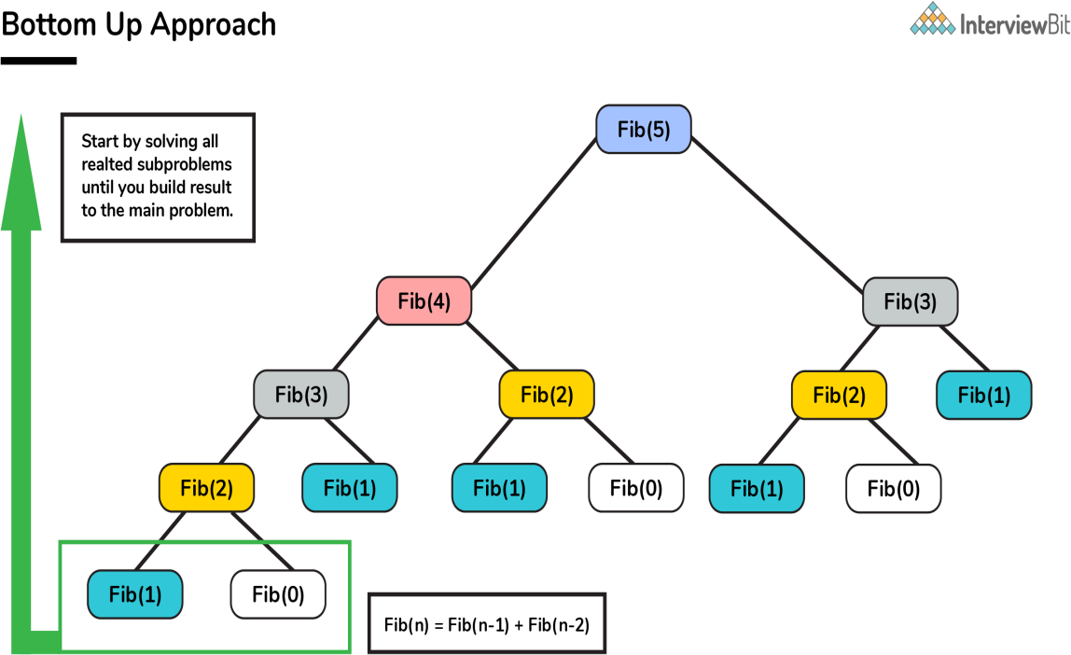

# DP APPLICATIONS TO IMPROVE DECISION MAKING

Additional issue that restricts the use of DP is that the target function

that many organizations are optimizing is hazy and ambiguous. In economics, the default assumption by government companies is to maximize their market share. This is the expected trickle of future earnings reduced at a riskadjusted discount factor. Conversely, a significant body of financial evidence on the disproportionate stock price volatility market prices poses serious reservations about what the firm's net worth is comparable to its fundamental value, which is the estimated present value of its future income flow.

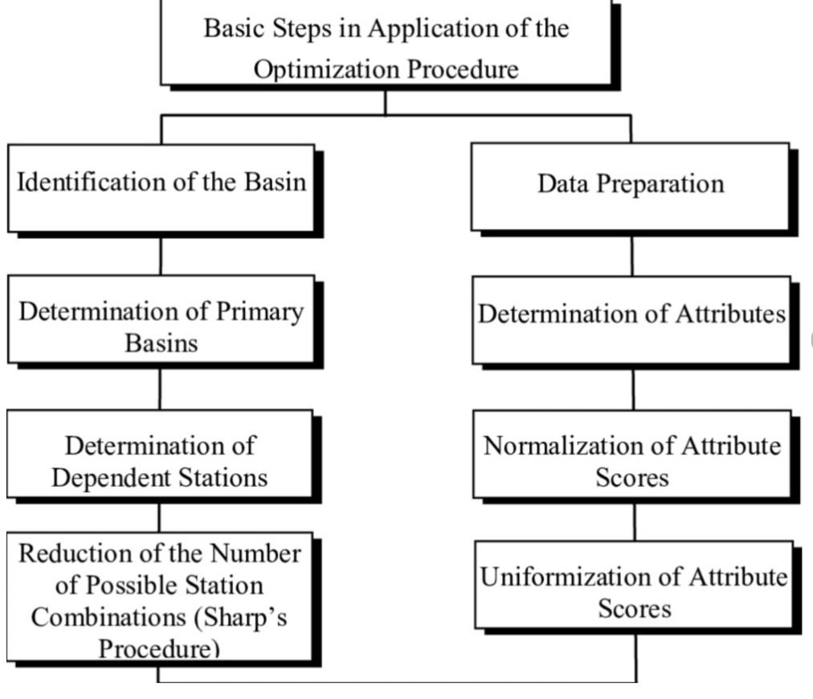

**EMPIRICAL DYNAMIC PROGRAMMINGAND THE IDENTIFICATION PROBLEM**

The advancements in numerical DP paved the door for a burgeoning literature on empirical estimate and testing of SDPs and dynamic games. The existing knowledge on estimate of dynamic labor demand schedules in a linear quadratic framework began to condense around the end of the 1970s, at the same time as a number of publications appeared that gave diverse methodologies.

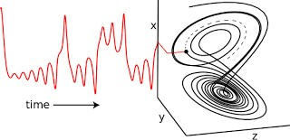

# CONCLUSION

Dynamic programming (DP) is an exceptionally strong approach for handling a wide range of uncertain sequential decision problems. Indeed, it's difficult to imagine an issue that can't be expressed and solved with Dynamic programming.